**Databases Laboratory Work Nr 1**

**Title: Installation and Configuration of MS SQL Server 2017**

**Prerequisites: Device with internet connection, patience**

**Objectives: Setup and Understanding of basic MS SQL Server features**

**Tasks: Download, install, feature checking, connection establishment, service initialization, server registration, user creation and assignment, roles management**

**Implementation:**  
**Configuration management. Initial services working well, nothing changed.**

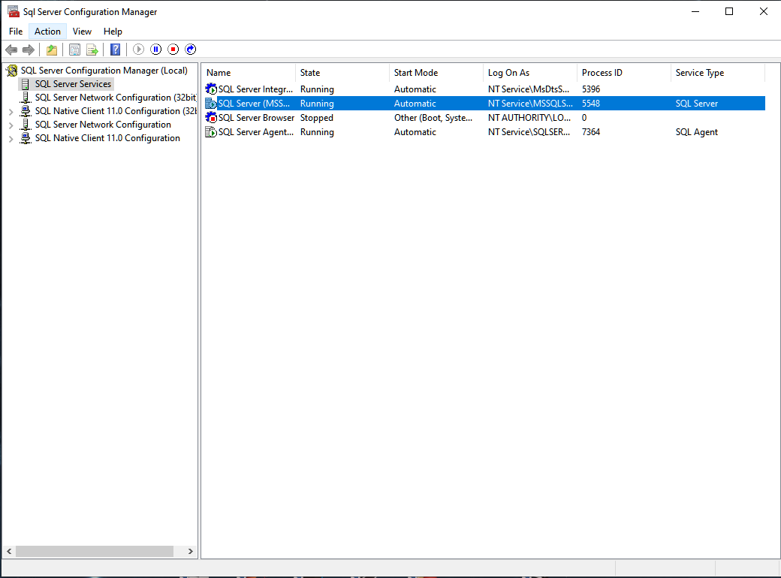

**Authentication via SQL Server Auth.**

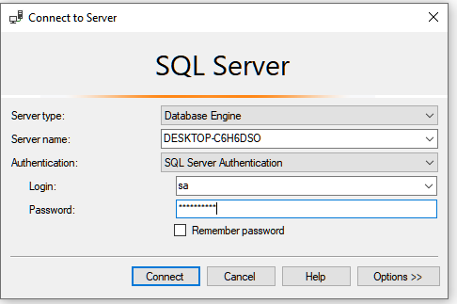

**After the DB has been registered, new logins have been added**  
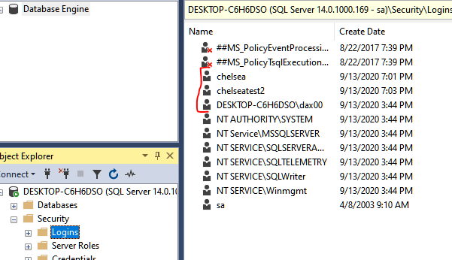

**Quick look upon Login Properties**  
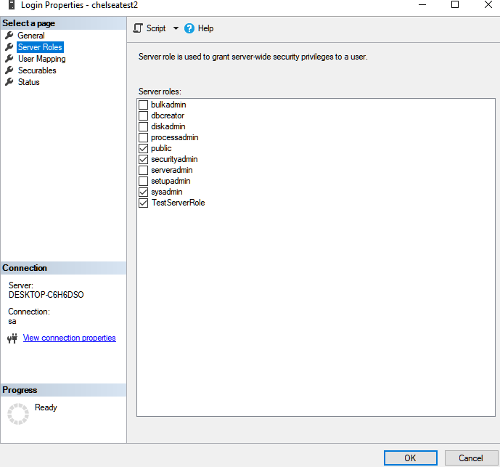

**All 3 logins have different roles and mappings, thus they have different levels of access to the data which will be stored in the future.**

**Conclusion**

**The process of installation and setup of MS SQL Server 2017 is a bit complex as it has a lot of features and requires a disk burner to be installed.**   
 **Basic setup of a SQL Database is also pretty complex as its UI is not really beginner friendly, but with some documentation and tutorials it can be passed through. Authentication phase can be hybrid, as users can login via SQL Username or Windows User Auth.**